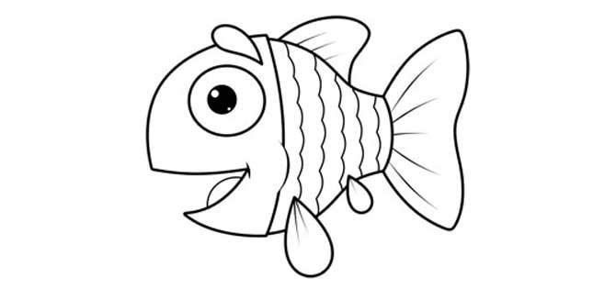
fish:……………………………………………./…………………………………………………….
……………………………………………./………………………………………………………….

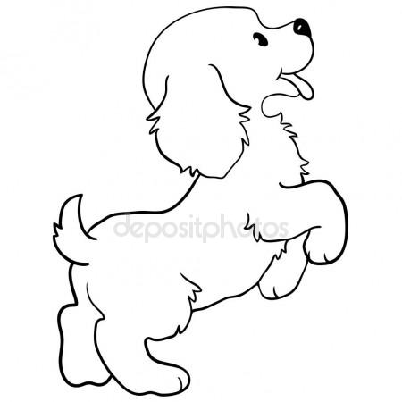dog:…………………………………………./……………………………………
……………………………………………………………../………………………………………………………

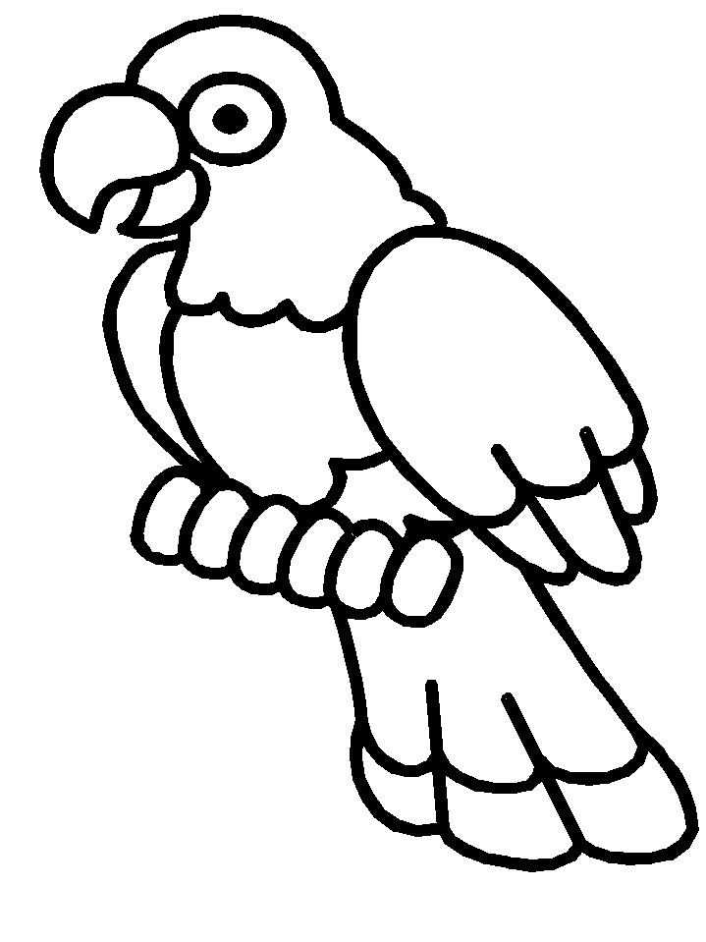 bird:………………………………………………./…………………………….………………………
…………………………………………………………./…………………………………………………….

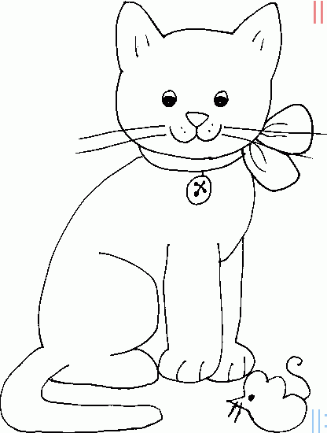cat:……………………………………………../………………………………………
……………………………………………………/………………………………………………

